**Investigation 1**

**Topic 3.1: Further Differentiation and Applications**

**Name________________________________ Due Date______________________________**

**Course-related information**

The concepts and skills included in this investigation relate to the following dot points within the WA Mathematics Methods syllabus:

* + 1. use the increments formula: $δy≈\frac{dy}{dx}×δx$ to estimate the change in the dependent variable $y$ resulting from changes in the independent variable $x$
    2. examine the concepts of concavity and points of inflection and their relationship with the second derivative
    3. apply the second derivative test for determining local maxima and minima
    4. sketch the graph of a function using first and second derivatives to locate stationary points and points of inflection
    5. solve optimisation problems from a wide variety of fields using first and second derivatives

**Background information**

This task investigates the connection between the second derivative and the concavity of a function. Students will investigate an optimisation problem and the estimated effect of varying an independent variable on a dependent variable using the small change or increments formula. Students should be able to apply both the first and second derivatives to solve optimisation problems.

Students will not be asked to differentiate exponential or trigonometric functions.

**Task conditions**.

A preparation activity is provided for students to work through before attempting the in-class validation. They should be provided with the opportunity to check their working and conclusions from this preparation activity. Students should not be permitted access to their preparation material during the validation, which should take 40 – 50 minutes to complete.

Use of a graphical/CAS calculator is assumed.

**Investigation 1 (Prepatory Component 60%)**

**Water Storage Tank**

**This investigation is to be a written report outlining the problem and the mathematics used to derive your findings. The rubric will be attached to the investigation. Refer to the rubric to see where marks are awarded.**

**Introduction**

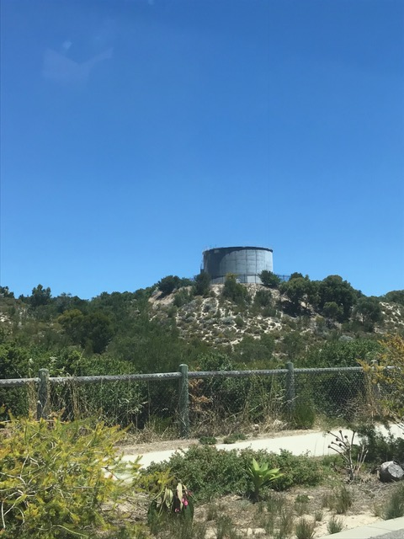Western Australia is home to some beautiful hills, which many people reside in. Supplying these people with water involves placing water tanks in remote and steep hills as can be seen in the picture above. Unfortunately, these are an eyesore so the designer must try to minimise the surface area. The water tanks also need to be situated on a flat surface at the highest possible point. Also at the lowest point in the hills there needs to be pressure valves to assist the water flow.

**Task 1 (5 marks)**

Below is an equation of a graph from a set of hills in a remote area where a water tank needs to be built. The tank needs to be at the highest point and the pressure valve is used to both increase and decrease water pressure. The first pressure valve needs to be placed at the point where the gradient first starts to slow naturally and at the point where the water will need to be pushed back up the hill.

$y=x^{3}-1.5x^{2}-18x+4$

Your task is to sketch the graph, and mark on the sketch where you would put the tank and the pressure valves. In your report you should explain with mathematical findings why you chose to put them there.

**Task 2 (5 marks)**

The water tank has a capacity of 90000 litres. Western Australian Councils don’t want the landscape to be affected so want the minimum possible surface area. Investigate by finding the minimum surface area of 4 different vessels, through your knowledge of differentiation, using your optimisation techniques to decide what shape your water tank should be. (one should be a cylinder).

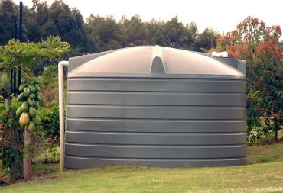

**Task 3 (8 marks)**

Investigate the percentage change in height, given a small% increase in capacity.

Calculate the percentage change in capacity if the height increases by 2%

Marking criteria

|  |  |  |  |  |  |
| --- | --- | --- | --- | --- | --- |
| **Marks awarded for the following** | 1 Marks | 2 Marks | 3Marks | 4 Marks | 5 marks |
| Presentation.  (Whole investigation) | Some structure  Some communication. | Clarity  Organisation  Communication  Well structured. |  |  |  |
| Graph and location of water tank.  (Task 1) | Sketching graph. | Sketching graph and finding the y-intercept. | Sketching graph and finding 2 stationary point. | Sketching graph and finding stationary and inflection points. | Sketching graph and finding stationary/ inflection points and nature. |
| Optimise Surface Area to give volume of 90kL.  (Task 2) | Cylinder. | Cylinder plus another vessel. | Cylinder plus 2 other vessels. | Cylinder plus 4 other vessels. | Reflect on which is likely to be the best vessel giving reasons. |
| Investigate the % change in Height given increase in capacity.  (Task 3) | Calculate % change in height once. | Calculate % change in height by doing once for at least 2 vessels. | Calculate the impact of 3 different increases on at least two vessels. | Calculate the impact of a 3 different increases on Surface Area for 4 vessels. | Calculate the impact of changes in 2 dimensions separately, on each vessel.  Comment on findings. |
| Calculate the % change in capacity given a 2% increase in height.  (Task 3) | Attempted percentage change but had 1 error. | Calculated correctly on cylinder. | Calculated correctly on each vessel. Comment on findings. |  |  |

Take home element - 20 marks

Validation - 10 marks

****Name**

**Date**

**Validation Investigation 1 (In class component 50%)**

**Time 40 min**

**Marks available 10**

Q1) Sketch the graph of $y=x^{3}+{3x}^{2}-12x-8$**(5 marks)**

The sketch should include location and nature of all stationary points?

Q2) What is the minimum Surface area of the cuboid if the maximum volume is 6000m3? **(3 marks)**

x

x

y

Q3) Calculate the percentage change needed in the height of the tank above, given a 3% increase in capacity. **(2 mark)**

